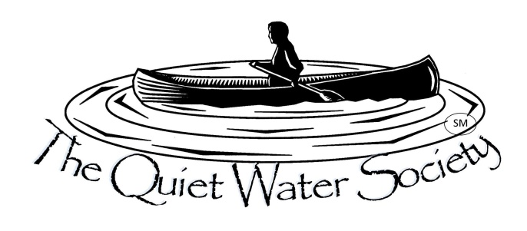
The Quiet Water Society—P.O. Box 27412, Lansing, MI 48909-7412—Contact: info@QuietWaterSociety.org—QuietWaterSociety.org

Press Release Press Release Press Release Press Release Press Release Press Release Press Release

The 22nd Annual Quiet Water Symposium
Saturday, March 4, 2017 9:00 to 5:30 PM
Michigan State University Pavilion
4301 Farm Lane, East Lansing MI
“Outdoor Michigan’s Favorite Indoor Show”

Several thousand of the Great Lakes area’s most enthusiastic out-of-doors adventurers will meet for what has become the “Unofficial Start of Spring” in the northern mid-west and you are welcome to join them. For nearly a quarter of a century, the Quiet Water Society and the Michigan State University College of Agriculture and Natural Resources have hosted this event as a key part of the ANR Week celebration.
This year’s symposium will feature presentations by over 30 of North America’s most intrepid outdoor adventurers and acclaimed outdoor writers. Gary and Joanie McGuffin and Hap Wilson join Canada’s “Happy Camper” Kevin Callan and the Dean of outdoor experts, Cliff Jacobson, to share their expertise, insight and love of the outdoors. Whether you love paddle sports, hiking, cycling, camping, sailing, fishing or just finding out how you can better conserve our natural wonders this is the place for you.
In addition to the presentations, you will find over 160 exhibits and demonstrations each designed to entertain and inform on all manner of non-motorized outdoor recreation and conservation. Learn to tie a fly, re-store a canoe or build a kayak. Find out about the latest in gear from our many exhibiting vendors. You can buy a Subaru or book an eco-adventure. From 8 to 80 if you like the outdoors, you will find activities and exhibits that will amaze and amuse.
Parking is free and we now have a free shuttle bus to and from our overflow lot on the corner of Mt. Hope and Farm Lane. Bring your family and friends and plan to stay all day. Admission: Adult $10, Students W/ID $5, Under 12 Free
The Quiet Water Society thanks its many sponsors and supporters: Michigan Department of Natural Resources, Williams Subaru, Johnsons Workbench, Mackinaw Watercraft, Riverside Kayak Connection, Founders Brewing Company, EagleMonk Pub and Brewery, Moosejaw Mountaineering, Quiet World Sports, The Power of Water, Gun Lake Paddle Sports, Columbia Wooden Boat Works, Wenonah Canoe, Northstar Canoes, Unadilla Boatworks, LeValley Outdoors, Red Cedar Fly Fishers, The Wooden Canoe Shop and many more.
For more information, show videos and photos please visit our website, QuietWaterSociety.org, or write: Allen@MackinawWatercraft.com

