Quiet Water Society
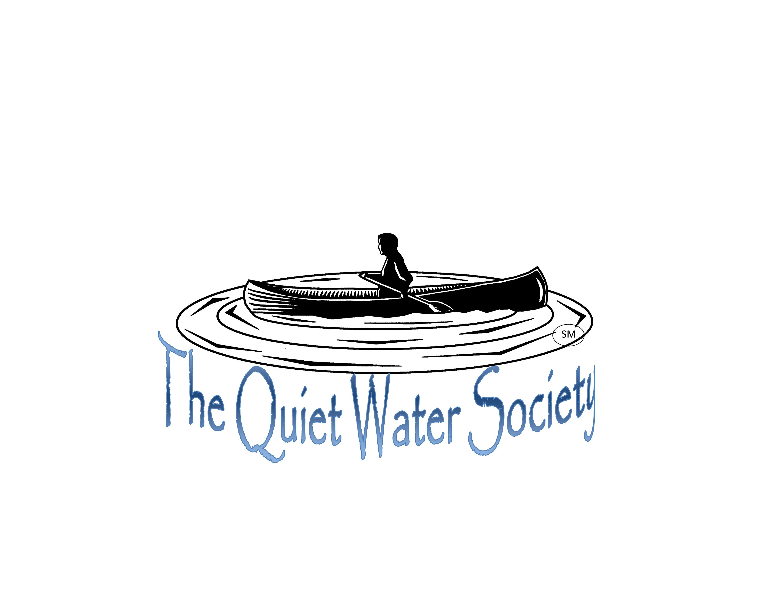
P.O. Box 27412
Lansing, MI 48909-7412

2019 Verlen Kruger Award

The Verlen Kruger Award is given annually to a person (or persons) who has supported and promoted conservation and paddle sports in Michigan. If you would like to nominate a recipient for the Verlen Kruger award, please complete the following form. Each nomination must be supported by two additional people. This can be in the form of a short email in support of the nominee and sent to the email address below. Please include your own e-mail address so that we can confirm your submission and follow up with any questions we may have. Save this form when completed and submit a copy, as an attachment, to the email address below. Thanks.

Name of nominee: Click or tap here to enter text.

How has the nominee contributed to conservation and paddle sports (up to 300 words): Click or tap here to enter text.

Resources available to verify the accomplishments of the nominee (reference websites, publications or news reports): Click or tap here to enter text.

Support for this nomination will also come from:
Name: Click or tap here to enter text.
Name: Click or tap here to enter text.

Your name: Click or tap here to enter text.

Your e-mail address: Click or tap here to enter text.

You telephone number (optional): Click or tap here to enter text.

