FOR IMMEDIATE RELEASE:
2017 Quiet Water Symposium
Lansing, MI - November 16, 2016 - The Quiet Water Society is pleased to announce the dates for our 22nd Annual Quiet Water Symposium. We are excited to once again join Michigan State University’s College of Agriculture and Natural Resources, ANR Week Celebration. In the nearly quarter of a century of promoting non-motorized outdoor recreation, the Quiet Water Society has never had an easier or more interesting time.
Those who have not visited this event in the last few years will be amazed at its growth and diversity. Last year’s Symposium featured over 200 exhibits, speakers and demonstrations at the MSU Pavilion. The March 4th event will feature presentations by noted travel writers, Jim DuFresne, Kevin Callan, Hap Wilson and the dean of outdoor writers, Cliff Jacobson.
One of the historic highpoints of the Quiet Water Symposium is celebrating the giving of the Verlen Kruger Award. This honor is given annually to a person (or persons) who has supported and promoted paddle sports along with water conservation, education, or history in Michigan. The recipient of this award receives a commemorative paddle, and a brick on which the date and the name of the recipient is engraved. A duplicate brick will be added to the walkway around the Verlen Kruger Memorial located by the Grand River in Portland, Michigan. The recipient’s name is also engraved on a plaque that is housed at the AuSable River Center in Roscommon, Michigan.
The first Saturday of March has become the official start of spring for the outdoor people of the Great Lakes. Campers, hikers, cyclists, sailors, anglers, and of course paddle sport enthusiasts will find this year’s symposium to be the nexus for beginning their 2017 outdoor adventures.
Please make plans to bring your family, friends and/or organization to the 22nd Annual Quiet Water Symposium.
When: Saturday, March 4, 2017
Where: Michigan State University Pavilion, 4309 Farm Lane, Lansing, MI
Time: 9:00 AM to 5:30 PM
Cost: Adults $10.00, Students with I/D $5.00, under 12 free.

For more details, visit our website at http://www.quietwatersociety.org/, see us on Facebook or contact info@quietwatersociety.org.

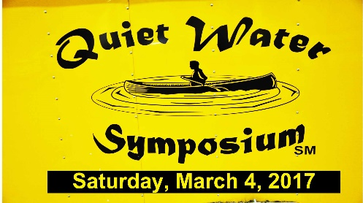

END
###

